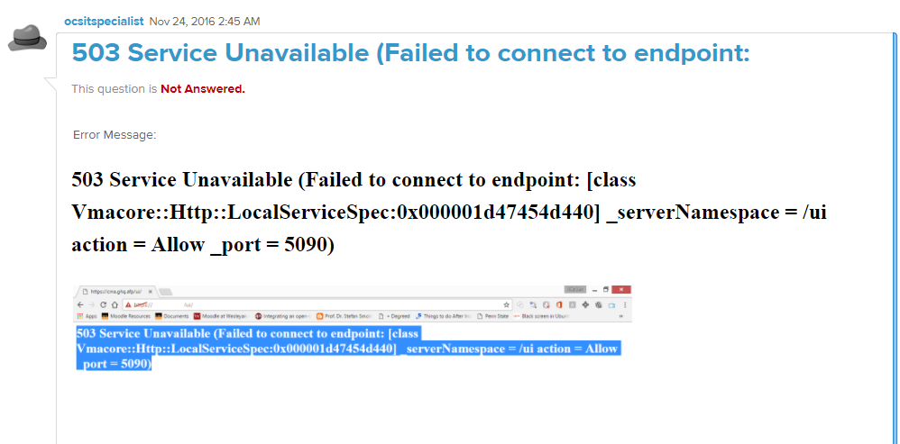

Vcenter will not open after reboot and it will show this page .

Resolution :

Services.msc

>stop the service named “WinHTTP Web Proxy Auto-Discovery Service ”

Service display name **WinHTTP Web Proxy Auto-Discovery Service**

**Service name :** **WinHttpAutoProxySvc**

**Description : WinHTTP implements the client HTTP stack and provides developers with a Win32 API and COM Automation component for sending HTTP requests and receiving responses. In addition, WinHTTP provides support for auto-discovering a proxy configuration via its implementation of the Web Proxy Auto-Discovery (WPAD) protocol.**

**Then give it a try it will work**

**[How to identify exact drive VMDK from The VM](https://communities.vmware.com/message/2686168" \l "2686168)**

If we are increasing VMDK of windows VM

OS End

C Drive 60GB

D Drive 100GB

E Drive 100Gb

F Drive 100Gb

I want to increase E Drive  to 150GB,

My question is how to identify exact E drive VMDK from The VM.

[I have the same question](https://communities.vmware.com/thread/567483" \o "I have the same question) Show 0 Likes[(0)](https://communities.vmware.com/thread/567483)

* 89 Views
* Tags:
* [**1.**](https://communities.vmware.com/message/2686087#2686087)[**Re: How to identify exact drive VMDK from The VM**](https://communities.vmware.com/message/2686087#2686087)

Hot Shot

[**vijayrana968**](https://communities.vmware.com/people/vijayrana968)Jul 4, 2017 4:31 AM ([in response to prakash9339](https://communities.vmware.com/message/2686168#2686168))

In Windows VM, open Disk Management.

[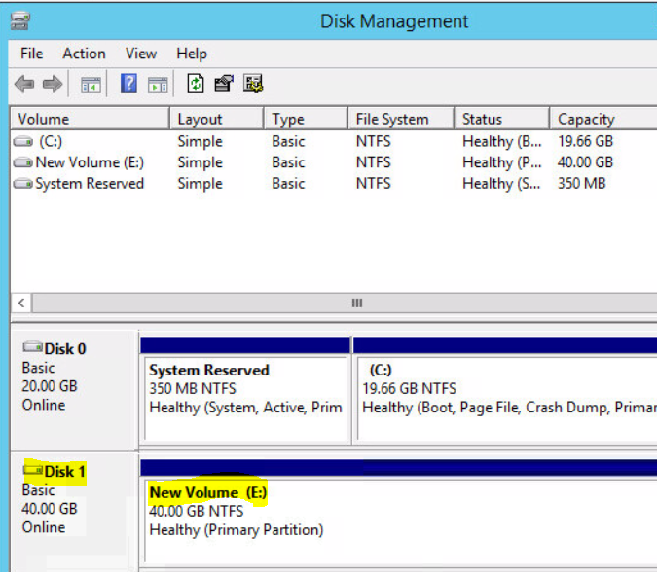](https://communities.vmware.com/servlet/JiveServlet/showImage/2-2686087-110340/pastedImage_1.png)

As you can see, E: volume is on Disk1 which is 40 GB. Now go to VM settings and find the disk

[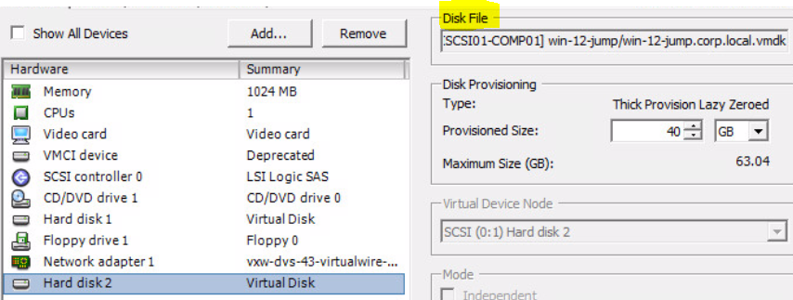](https://communities.vmware.com/servlet/JiveServlet/showImage/2-2686087-110341/pastedImage_2.png)

* [**2.**](https://communities.vmware.com/message/2686183#2686183)**[Re: How to identify exact drive VMDK from The VM](https://communities.vmware.com/message/2686183" \l "2686183)**

In Windows VM, open Disk Management. Right click the specific disk and go to properties.

Note the Location bus number and target ID.

[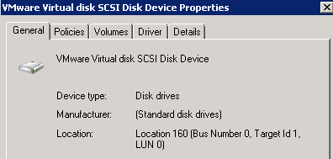](https://communities.vmware.com/servlet/JiveServlet/showImage/2-2686183-110334/pastedImage_0.png)

Go to viclient and find the disk.

Match the bus number and target id with the SCSI number under Virtual Device Node.

Hope its clear